Programming Fundamentals Assignment

PROGRAM 1:

Error Identification and Corrections
Line No. | Error Type | Error Description | Correction
8 | Syntax Error | Missing semicolon after int x = 10 | int x = 10;
13 | Logical Error | Assignment operator = used instead of comparison operator | if(x == 10)
18 | Semantic Error | String assigned to integer variable | int marks = 90;
20 | Semantic Error | Variable z is not declared | int z = 50;
22 | Syntax Error | Cannot assign value to a constant (100 = x) | x = 100;
26 | Logical Error | Array index out of bounds (arr[10]) | Use index between 0 and 4
28 | Semantic Error | Incompatible pointer type | int *ptr = &x;
30 | Semantic Error | Wrong format specifier %f used for integer variable | printf("%d\n", x);
35 | Runtime Error | Division by zero (a/b) | Assign non-zero value to b
37 | Semantic Error | Multi-character character constant 'AB' | char ch = 'A';
42 | Logical Error | Same message printed in both if and else blocks | Else block should print "Y is greater"
45 | Logical Warning | Return value of sqrt(25) is ignored | Store or print the result
47 | Semantic Error | Function show() is not declared or defined | Define show() or remove function call
49 | Logical Error | Extra semicolon after while(x < 15) | Remove semicolon
55 | Semantic Error | continue used outside a loop | Remove statement or place inside loop
57 | Semantic Error | break used outside loop/switch | Remove statement or place inside loop/switch
59 | Semantic Error | Function calculate() called with one argument instead of two | calculate(10, 20)
Total Errors Identified: 17
Corrected Program:
#include <stdio.h>
#include <math.h>
int calculate(int a, int b);
int main()
{
int x = 10;
int y = 20;

printf("Program Started\n");
if(x == 10)
{
printf("X is 10\n");
}
int marks = 90;
int z = 50;
printf("%d\n", z);
x = 100;
int arr[5];
arr[4] = 50;
int *ptr = &x;
printf("%d\n", x);
int a = 10;
int b = 2;
printf("%d\n", a/b);
char ch = 'A';
if(x > y)
printf("X is greater");
else
printf("Y is greater");
printf("\n%.2f\n", sqrt(25));
while(x < 15)
{
x++;
}
int result = calculate(10, 20);
printf("%d\n", result);
printf("Program Ended\n");
return 0;
}
int calculate(int a, int b)
{
return a + b;
}
Program output:
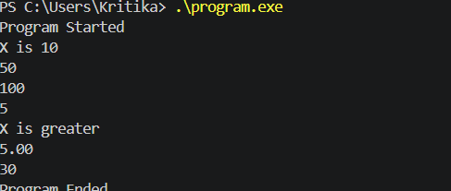

PROGRAM 2
Error Identification and Corrections
Line No. | Error Type | Error Description | Correction
8 | Syntax Error | Missing semicolon after int num2 = 20 | int num2 = 20;
18 | Syntax Error | Missing closing parenthesis in if(choice == 1 | if(choice == 1)
30 | Syntax Error | Extra closing parenthesis in else if(choice == 3)) | else if(choice == 3)
45 | Syntax Error | Missing closing parenthesis in for(int i=0; i<5; i++ | for(int i=0; i<5; i++)
52 | Syntax Error | Missing closing parenthesis in while(choice > 0 | while(choice > 0)
60 | Syntax Error | Missing semicolon after while(choice > 5) in do-while loop | while(choice > 5);
67 | Syntax Error | Missing colon after case 2 | case 2:
91 | Syntax Error | Missing closing quote in char grade = 'A; | char grade = 'A';
95 | Syntax Error | Missing closing bracket in int arr[5; | int arr[5];
109 | Logical Error | Opening block { does not have proper closing brace before program end | Add missing }
123 | Syntax Error | Missing semicolon after printf("End of Program\n") | printf("End of Program\n");
Total Errors Identified: 11
Corrected Program
#include <stdio.h>
int add(int a, int b);
int main()
{
int choice;
int num1 = 10;
int num2 = 20;
int result;
printf("=== MENU ===\n");
printf("1. Add\n");
printf("2. Subtract\n");
printf("3. Multiply\n");
printf("4. Divide\n");
printf("Enter choice: ");
scanf("%d", &choice);
if(choice == 1)
{
result = num1 + num2;
printf("Result = %d\n", result);
}
else if(choice == 2)
{
result = num1 - num2;
printf("Result = %d\n", result);
}
else if(choice == 3)
{
result = num1 * num2;
printf("Result = %d\n", result);
}
else if(choice == 4)
{
result = num1 / num2;
printf("Result = %d\n", result);
}
else
{
printf("Invalid Choice\n");
}
for(int i=0; i<5; i++)
{
printf("%d ", i);
}
printf("\n");
while(choice > 0)
{
choice--;
}
do
{
printf("Processing...\n");
}
while(choice > 5);
switch(choice)
{
case 1:
printf("One\n");
break;
case 2:
printf("Two\n");
break;
default:
printf("Other\n");
}
int marks = 80;
if(marks >= 90)
{
printf("Grade A\n");
}
else if(marks >= 80)
{
printf("Grade B\n");
}
else if(marks >= 70)
{
printf("Grade C\n");
}
else
{
printf("Grade D\n");
}
char grade = 'A';
printf("Grade = %c\n", grade);
int arr[5];
arr[0] = 10;
arr[1] = 20;
arr[2] = 30;
printf("%d\n", arr[0]);
if(arr[0] > 5)
{
printf("Greater\n");
}
{
printf("Block Start\n");
if(arr[1] > 10)
{
printf("Condition True\n");
}
}
printf("Still Running\n");
for(int j=0; j<3; j++)
{
printf("%d\n", j);
}
printf("End of Program\n");
return 0;
}
int add(int a, int b)
{
return a + b;
}
Output:
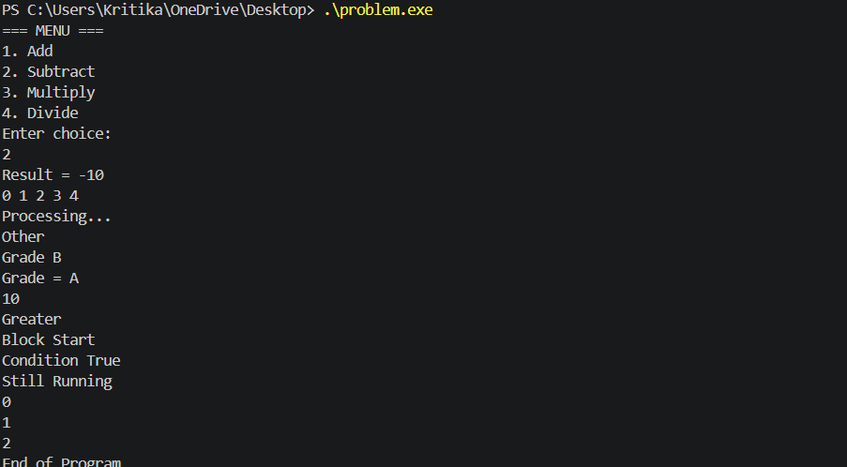

PROGRAM 3
Error Identification and Corrections
Line No. | Error Type | Error Description | Correction
7 | Semantic Error | String assigned to integer variable | int age = 20;
13 | Semantic Error | Double quotes used for character | char grade = 'A';
15 | Format Specifier Error | %d used for float variable salary | printf("%f\n", salary);
17 | Format Specifier Error | %f used for integer variable marks | printf("%d\n", marks);
21 | Semantic Error | Variable score not declared | Declare score or replace with valid variable
24 | Semantic Error | Duplicate declaration of variable x | Remove one declaration
26 | Syntax Error | Cannot assign value to constant (100 = x) | x = 100;
30 | Format Specifier Error | %s used for integer variable num | printf("%d\n", num);
34 | Format Specifier Error | %d used for float variable pi | printf("%f\n", pi);
38 | Semantic Error | Array index cannot be float (arr[2.5]) | Use integer index such as arr[2]
40 | Semantic Warning | Decimal value assigned to char variable | char ch = 'A';
44 | Semantic Error | Function add() called with one argument instead of two | add(10,20)
50 | Semantic Error | Function average() called with two arguments instead of three | average(10,20,30)
54 | Semantic Error | String assigned to integer variable | int temperature = 35;
58 | Semantic Error | String assigned to float variable | float discount = 10.5;
66 | Syntax Error | Cannot assign string directly to character array | strcpy(name,"Robil");
72 | Semantic Error | Variable totalMarks not declared | Declare variable before use
82 | Format Specifier Warning | %c used for integer variable | Use %d
86 | Format Specifier Error | %d used for float variable rate | %f
94 | Semantic Error | Variable c not declared in function call | Declare c or use valid value
102 | Logical Error | Area stored in integer variable causing loss of precision | Use float area;
109 | Logical Error | Assignment operator used in condition | if(studentMarks == 100)
115 | Semantic Error | String assigned to integer variable | int size = 1;
120 | Format Specifier Error | %d used for float variable percentage | %f
124 | Semantic Error | String used as array index | Use integer index
133 | Semantic Error | "2" is string literal instead of integer case label | case 2:
140 | Semantic Error | Function multiply() not declared or defined | Define function or remove call
152 | Format Specifier Error | %d used for float variable areaRect | %f
160 | Logical Error | Average stored in integer variable causing loss of precision | Use float avgMarks;
166 | Semantic Error | Variable value not declared | Declare variable before use
168 | Semantic Error | String assigned to integer variable | Use string array
170 | Format Specifier Error | %d used for string value | %s
Total Errors Identified: 31
Corrected Program
#include <stdio.h>
#include <string.h>
int add(int a, int b);
float average(int a, int b, int c);
int main()
{
int age = 20;
float salary = 50000.50;
int marks = 85;
char grade = 'A';
printf("%f\n", salary);
printf("%d\n", marks);
int score = 15;
int total;
total = marks + score;
int x = 10;
x = 20;
x = 100;
int num = 25;
printf("%d\n", num);
float pi = 3.14;
printf("%f\n", pi);
int arr[5];
arr[2] = 100;
char ch = 'A';
int result;
result = add(10,20);
printf("%d\n", result);
float avg;
avg = average(10,20,30);
printf("%f\n", avg);
int temperature = 35;
int amount = 1000;
float discount = 10.5;
amount = amount - discount;
char name[20];
strcpy(name,"Robil");
printf("%s\n", name);
int totalMarks = 90;
int count;
count = totalMarks + 10;
int number = 50;
printf("%d\n", number);
float rate = 7.5;
printf("%f\n", rate);
int a = 10;
int b = 20;
int c = 30;
int sum;
sum = add(a,b);
printf("%d\n", sum);
float radius = 5.5;
float area;
area = 3.14 * radius * radius;
printf("%f\n", area);
int studentMarks = 90;
if(studentMarks == 100)
{
printf("Perfect Score\n");
}
int size = 1;
printf("%d\n", size);
float percentage = 89.75;
printf("%f\n", percentage);
int arr2[10];
arr2[5] = 100;
int choice = 2;
switch(choice)
{
case 1:
printf("One\n");
break;
case 2:
printf("Two\n");
break;
}
float areaRect;
int length = 10;
int width = 5;
areaRect = length * width;
printf("%f\n", areaRect);
int marks1 = 70;
int marks2 = 80;
int marks3 = 90;
float avgMarks;
avgMarks = average(marks1, marks2, marks3);
printf("%f\n", avgMarks);
int value = 100;
printf("%d\n", value);
char employeeId[] = "EMP101";
printf("%s\n", employeeId);
return 0;
}
int add(int a, int b)
{
return a + b;
}
float average(int a, int b, int c)
{
return (a + b + c) / 3.0;
}
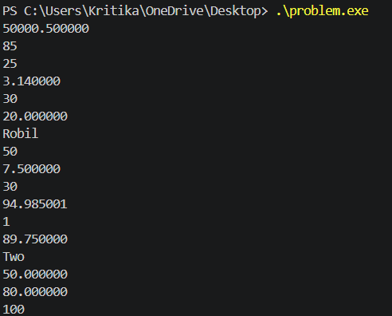
PROGRAM 4
Error Identification and Corrections
Line No. | Error Type | Error Description | Correction
11 | Semantic Error | companyProfit declared as extern but not defined anywhere | Define float companyProfit = value;
42 | Semantic Error | Function generateReport() called but not declared/defined | Create function definition or remove call
44 | Semantic Error | Function displayEmployee() called but not declared/defined | Create function definition or remove call
46 | Semantic Error | Function processData() called but not declared/defined | Create function definition or remove call
48 | Semantic Error | Function saveRecord() called but not declared/defined | Create function definition or remove call
50 | Semantic Error | Function loadRecord() called but not declared/defined | Create function definition or remove call
52 | Semantic Error | Function printInvoice() called but not declared/defined | Create function definition or remove call
54 | Semantic Error | Function calculateTax() called but not declared/defined | Create function definition or remove call
56 | Semantic Error | Function validateUser() called but not declared/defined | Create function definition or remove call
58 | Semantic Error | Function sendNotification() called but not declared/defined | Create function definition or remove call
60 | Semantic Error | Function generateCertificate() called but not declared/defined | Create function definition or remove call
29 | Semantic Error | Function showResult() declared but not defined | Define function
4 | Semantic Error | Function calculateSalary() declared but not defined | Define function
7 | Semantic Error | Function printStudentDetails() declared but not defined | Define function
9 | Semantic Error | Function calculateAverage() declared but not defined | Define function
Total Errors Identified: 15
Corrected Program
#include <stdio.h>

void displayMenu();
void calculateSalary(float basic);
int add(int a, int b);
float calculateArea(float radius);
void printStudentDetails();
int findMaximum(int a, int b);
void showResult();
float calculateAverage(int a, int b, int c);

int totalStudents = 500;
float companyProfit = 100000.50;

void generateReport()
{
printf("Report Generated\n");
}

void displayEmployee()
{
printf("Employee Details\n");
}

void processData()
{
printf("Processing Data\n");
}

void saveRecord()
{
printf("Record Saved\n");
}

void loadRecord()
{
printf("Record Loaded\n");
}

void printInvoice()
{
printf("Invoice Printed\n");
}

void calculateTax()
{
printf("Tax Calculated\n");
}

void validateUser()
{
printf("User Validated\n");
}

void sendNotification()
{
printf("Notification Sent\n");
}

void generateCertificate()
{
printf("Certificate Generated\n");
}

int main()
{
int choice = 1;

displayMenu();

int sum = add(10,20);
printf("Sum = %d\n", sum);

float area = calculateArea(7.5);
printf("Area = %.2f\n", area);

calculateSalary(50000);

printStudentDetails();

int max = findMaximum(10,20);
printf("Max = %d\n", max);

showResult();

float avg = calculateAverage(70,80,90);
printf("Average = %.2f\n", avg);

printf("Students = %d\n", totalStudents);
printf("Profit = %.2f\n", companyProfit);

generateReport();
displayEmployee();
processData();
saveRecord();
loadRecord();
printInvoice();
calculateTax();
validateUser();
sendNotification();
generateCertificate();

return 0;
}

void displayMenu()
{
printf("1. Add\n");
printf("2. Subtract\n");
printf("3. Exit\n");
}

void calculateSalary(float basic)
{
printf("Salary = %.2f\n", basic);
}

int add(int a, int b)
{
return a + b;
}

float calculateArea(float radius)
{
return 3.14f * radius * radius;
}

void printStudentDetails()
{
printf("Student Details\n");
}

int findMaximum(int a, int b)
{
return (a > b) ? a : b;
}

void showResult()
{
printf("Result Displayed\n");
}

float calculateAverage(int a, int b, int c)
{
return (a + b + c) / 3.0;
}
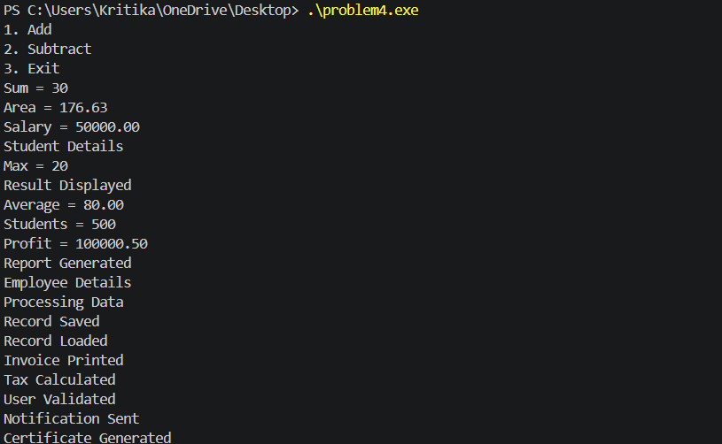
PROGRAM 5
Error Identification and Corrections
Line No. | Error Type | Error Description | Correction
10 | Runtime Error | Division by zero (a / b) | Ensure b != 0
14 | Runtime Error | Dereferencing NULL pointer (*ptr1) | Allocate memory or assign valid address
18 | Runtime Error | Array index out of bounds (arr[10]) | Use index between 0 and 4
22 | Runtime Error | Uninitialized pointer dereferenced (*ptr2) | Initialize pointer before use
26 | Runtime Error | Buffer overflow in strcpy() | Increase array size or reduce string length
32 | Runtime Error | Uninitialized pointer dereferenced (*ptr3) | Initialize pointer before use
38 | Runtime Error | File may not exist (unknown.txt) | Check fp != NULL before use
44 | Runtime Error | Buffer overflow in allocated memory | Allocate sufficient memory
50 | Runtime Error | Accessing memory after free() | Do not use pointer after freeing memory
56 | Runtime Error | Double free of pointer | Free memory only once
62 | Runtime Error | Modulus by zero (x % y) | Ensure y != 0
68 | Runtime Error | Buffer overflow using strcat() | Increase destination array size
76 | Runtime Error | Writing beyond allocated memory | Loop should run only up to allocated size
84 | Runtime Error | Matrix index out of bounds | Use valid indices 0-2
88 | Runtime Error | Accessing NULL pointer (ptr6[0]) | Allocate memory or assign valid address
92 | Security/Runtime Error | Unsafe use of gets() | Use fgets()
102 | Runtime Error | Using freed memory (*ptr7) | Do not access pointer after free()
106 | Runtime Error | Uninitialized variable age | Initialize variable before use
110 | Runtime Error | Negative array index | Use valid index
114 | Runtime Error | Uninitialized pointer used in condition | Initialize pointer before dereference
122 | Runtime Error | Printing NULL string pointer | Check pointer before printing
130 | Runtime Error | malloc() result not checked | Verify allocation success
138 | Logical/Runtime Error | Infinite loop | Add termination condition
Total Errors Identified: 23
Corrected Code:
#include <stdio.h>
#include <stdlib.h>
#include <string.h>

int main()
{
printf("Runtime Error Practice Program\n");

int a = 100;
int b = 5;

printf("Division Result = %d\n", a / b);

int value1 = 50;
int *ptr1 = &value1;

*ptr1 = 50;

int arr[5];
arr[4] = 100;

int value2 = 200;
int *ptr2 = &value2;

*ptr2 = 200;

char name[20];
strcpy(name, "Programming");

printf("%s\n", name);

int value3 = 300;
int *ptr3 = &value3;

printf("%d\n", *ptr3);

FILE *fp;

fp = fopen("test.txt", "r");

if(fp != NULL)
{
fscanf(fp, "%d", &a);
fclose(fp);
}

char *ptr4 = malloc(50);

strcpy(ptr4, "Computer Science");

printf("%s\n", ptr4);

free(ptr4);
ptr4 = NULL;

int *ptr5 = malloc(sizeof(int));

free(ptr5);
ptr5 = NULL;

int x = 5;
int y = 2;

int result = x % y;

printf("%d\n", result);

char str1[30] = "Hello";

strcat(str1, "World");

printf("%s\n", str1);

int *numbers;

numbers = malloc(10 * sizeof(int));

for(int i=0; i<10; i++)
{
numbers[i] = i;
}

free(numbers);

int matrix[3][3];

matrix[2][2] = 100;

int value6 = 500;
int *ptr6 = &value6;

printf("%d\n", ptr6[0]);

char password[20];

fgets(password, sizeof(password), stdin);

printf("%s\n", password);

int *ptr7 = malloc(sizeof(int));

*ptr7 = 500;

free(ptr7);
ptr7 = NULL;

int age = 20;

printf("Age = %d\n", age);

int index = 2;

arr[index] = 50;

int value8 = 5;
int *ptr8 = &value8;

if(*ptr8 > 0)
{
printf("Positive\n");
}

char text[] = "Hello";

printf("%s\n", text);

int size = 100;

int *hugeArray;

hugeArray = malloc(size * sizeof(int));

if(hugeArray != NULL)
{
hugeArray[0] = 1;
free(hugeArray);
}

int counter = 0;
while(counter < 5)
{
counter++;
}
printf("End of Program\n");
return 0;
}
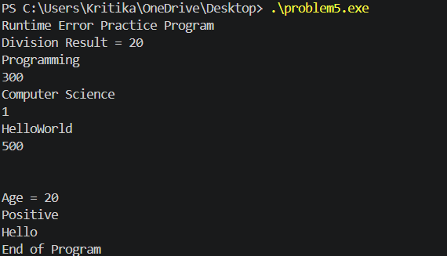

PROGRAM 6
Error Identification and Corrections
Line No. | Error Type | Error Description | Correction
12 | Logical Error | Even/Odd condition reversed | if(num % 2 == 0) for Even
22 | Logical Error | Grade A and Grade B conditions interchanged | >=90 → Grade A, >=80 → Grade B
35 | Logical Error | Leap year logic incomplete | Check century year conditions also
44 | Logical Error | Voting eligibility condition reversed | if(age >= 18) Eligible
54 | Logical Error | Largest/Smaller output incorrect | Print smaller number correctly
66 | Logical Error | Largest number logic uses < instead of > | Compare using >
80 | Logical Error | Integer division causes loss of decimal value | (float)totalMarks / subjects
90 | Logical Error | Wrong formula for circle area | 3.14 * radius * radius
100 | Logical Error | Bonus percentages incorrect | Usually higher bonus for higher salary
113 | Logical Error | Month names shifted by one position | Case 1 should print January
132 | Logical Error | Prime number logic incorrect | Set isPrime = 0 when divisible
137 | Logical Error | Prime/Not Prime output reversed | If prime → print Prime
151 | Logical Error | Discount added instead of subtracted | purchaseAmount - discount
161 | Logical Error | Sum logic incorrect | sum += i
171 | Logical Error | Temperature condition reversed | temperature > 40 → Hot
181 | Logical Error | Grade message incorrect | Grade A should be Excellent
194 | Logical Error | Rectangle area formula incorrect | length * width
203 | Logical Error | Pass/Fail condition reversed | >=60 should print Pass
Total Errors Identified: 18
Corrected Program
#include <stdio.h>

int main()
{
int num;
int marks;
int year;
int age;

printf("Enter a number: ");
scanf("%d",&num);

if(num % 2 == 0)
printf("Number is Even\n");
else
printf("Number is Odd\n");

printf("\n");

printf("Enter marks: ");
scanf("%d",&marks);

if(marks >= 90)
printf("Grade A\n");
else if(marks >= 80)
printf("Grade B\n");
else if(marks >= 70)
printf("Grade C\n");
else if(marks >= 60)
printf("Grade D\n");
else
printf("Fail\n");

printf("\n");

printf("Enter year: ");
scanf("%d",&year);

if((year % 400 == 0) || (year % 4 == 0 && year % 100 != 0))
printf("Leap Year\n");
else
printf("Not Leap Year\n");

printf("\n");

printf("Enter age: ");
scanf("%d",&age);

if(age >= 18)
printf("Eligible for Voting\n");
else
printf("Not Eligible for Voting\n");

printf("\n");

int a = 10;
int b = 20;

if(a < b)
printf("Smaller Number = %d\n", a);
else
printf("Smaller Number = %d\n", b);

printf("\n");

int x = 10;
int y = 20;
int z = 30;

int largest = x;

if(y > largest)
largest = y;

if(z > largest)
largest = z;

printf("Largest Number = %d\n", largest);

printf("\n");

int totalMarks = 250;
int subjects = 3;

float average;

average = (float)totalMarks / subjects;

printf("Average = %.2f\n", average);

printf("\n");

int radius = 7;

float area;

area = 3.14 * radius * radius;

printf("Circle Area = %.2f\n", area);

printf("\n");

int salary = 50000;

float bonus;

if(salary > 30000)
bonus = salary * 0.20;
else
bonus = salary * 0.02;

printf("Bonus = %.2f\n", bonus);

printf("\n");

int month = 4;

switch(month)
{
case 1: printf("January\n"); break;
case 2: printf("February\n"); break;
case 3: printf("March\n"); break;
case 4: printf("April\n"); break;
default: printf("Invalid Month\n");
}

printf("\n");

int n = 13;
int isPrime = 1;

for(int i=2;i<n;i++)
{
if(n % i == 0)
{
isPrime = 0;
break;
}
}

if(isPrime)
printf("Prime\n");
else
printf("Not Prime\n");

printf("\n");

int purchaseAmount = 5000;

float discount = 0;

if(purchaseAmount > 1000)
discount = 5;

float finalAmount;

finalAmount = purchaseAmount - discount;

printf("Final Amount = %.2f\n", finalAmount);

printf("\n");

int sum = 0;

for(int i=1;i<=10;i++)
{
sum += i;
}

printf("Sum = %d\n", sum);

printf("\n");

int temperature = 35;

if(temperature > 40)
printf("Hot Weather\n");
else
printf("Cold Weather\n");

printf("\n");

char grade = 'A';

if(grade == 'A')
printf("Excellent Performance\n");
else
printf("Average Performance\n");

printf("\n");

int length = 10;
int width = 5;

int rectangleArea;

rectangleArea = length * width;

printf("Rectangle Area = %d\n", rectangleArea);

printf("\n");

int percentage = 75;

if(percentage >= 60)
printf("Pass\n");
else
printf("Fail\n");

printf("\n");

printf("Program Completed Successfully\n");

return 0;
}
Output:
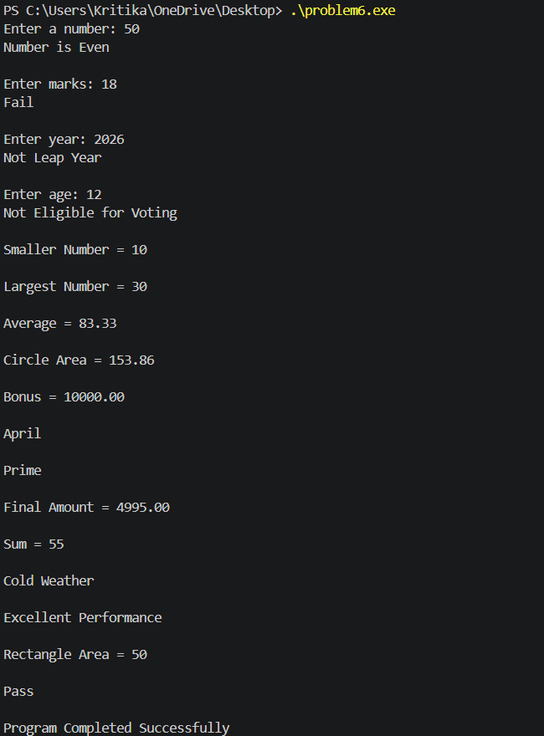

PROGRAM 7
Error Identification and Corrections
Line No. | Error Type | Error Description | Correction
8 | Logical Error | Loop condition i<=5 accesses marks[5] (out of bounds) | Use i<5
24 | Logical Error | Integer division used for average calculation | average = (float)total / 5;
30 | Runtime Error | Array index starts from 1 and accesses numbers[10] | Use i=0; i<10; i++
46 | Runtime Error | Buffer overflow in strcpy() | Increase array size or reduce string
54 | Syntax Error | Cannot assign string directly to array | Use strcpy(city,"Delhi");
63 | Logical Error | Strings compared using == | Use strcmp(str1,str2)
76 | Security Error | gets() is unsafe | Use fgets()
84 | Runtime Error | strcat() may overflow destination array | Increase array size
95 | Logical Error | String not null terminated | Add grade[2]='\0';
103 | Runtime Error | Negative array index arr[-1] | Use valid index
122 | Runtime Error | Array index out of bounds (scores[3]) | Array size should be 4 or remove access
136 | Logical Error | String compared using == | Use strcmp(username,"admin")==0
148 | Runtime Error | Buffer overflow in mobile array | Increase array size
158 | Runtime Error | Loop condition i<=5 accesses attendance[5] | Use i<5
168 | Runtime Error | Accessing course[20] out of bounds | Use valid index
181 | Logical Error | Character array not null terminated | Add college[5]='\0';
199 | Runtime Error | Array size too small for "IT-A" | Increase size to 5
Total Errors Identified: 17
Corrected Code:
#include <stdio.h>
#include <string.h>

int main()
{
int marks[5] = {80, 75, 90, 85, 95};

printf("Student Marks\n");

for(int i=0; i<5; i++)
{
printf("%d ", marks[i]);
}

printf("\n");

int total = 0;

for(int i=0; i<5; i++)
{
total += marks[i];
}

float average = (float)total / 5;

printf("Average = %.2f\n", average);

int numbers[10];

for(int i=0; i<10; i++)
{
numbers[i] = (i + 1) * 10;
}

printf("Numbers Array\n");

for(int i=0; i<10; i++)
{
printf("%d ", numbers[i]);
}

printf("\n");

char name[20];
strcpy(name, "ComputerScience");

printf("%s\n", name);

char city[20] = "Jaipur";

strcpy(city, "Delhi");

printf("%s\n", city);

char str1[20] = "Hello";
char str2[20] = "Hello";

if(strcmp(str1, str2) == 0)
{
printf("Strings are Equal\n");
}
else
{
printf("Strings are Different\n");
}

char password[20];

printf("Enter Password: ");
fgets(password, sizeof(password), stdin);

printf("Password = %s\n", password);

char firstName[40] = "Robil";
char lastName[20] = "Varshney";

strcat(firstName, lastName);

printf("%s\n", firstName);

char grade[5];

grade[0] = 'A';
grade[1] = '+';
grade[2] = '\0';

printf("%s\n", grade);

int arr[5] = {1,2,3,4,5};

printf("%d\n", arr[0]);

char department[20];

scanf("%19s", department);

printf("%s\n", department);

char email[25] = "student@gmail.com";

printf("%s\n", email);

int scores[4];

scores[0] = 90;
scores[1] = 80;
scores[2] = 70;
scores[3] = 60;

printf("%d\n", scores[3]);

char subject[15] = "Programming";

printf("%s\n", subject);

char username[20];

printf("Enter Username: ");
scanf("%19s", username);

if(strcmp(username, "admin") == 0)
{
printf("Valid User\n");
}
else
{
printf("Invalid User\n");
}

char mobile[15];

strcpy(mobile, "987654321012");

printf("%s\n", mobile);

int attendance[5] = {1,1,1,1,1};

int present = 0;

for(int i=0; i<5; i++)
{
present += attendance[i];
}

printf("Present Days = %d\n", present);

char course[20] = "C Programming";

printf("%c\n", course[0]);

char college[20];

college[0] = 'A';
college[1] = 'C';
college[2] = 'E';
college[3] = 'I';
college[4] = 'T';
college[5] = '\0';

printf("%s\n", college);

int rollNo[5];

for(int i=0; i<5; i++)
{
scanf("%d", &rollNo[i]);
}

printf("\nRoll Numbers\n");

for(int i=0; i<5; i++)
{
printf("%d ", rollNo[i]);
}

printf("\n");

char section[5] = "IT-A";

printf("%s\n", section);

printf("\nProgram Finished\n");

return 0;
}
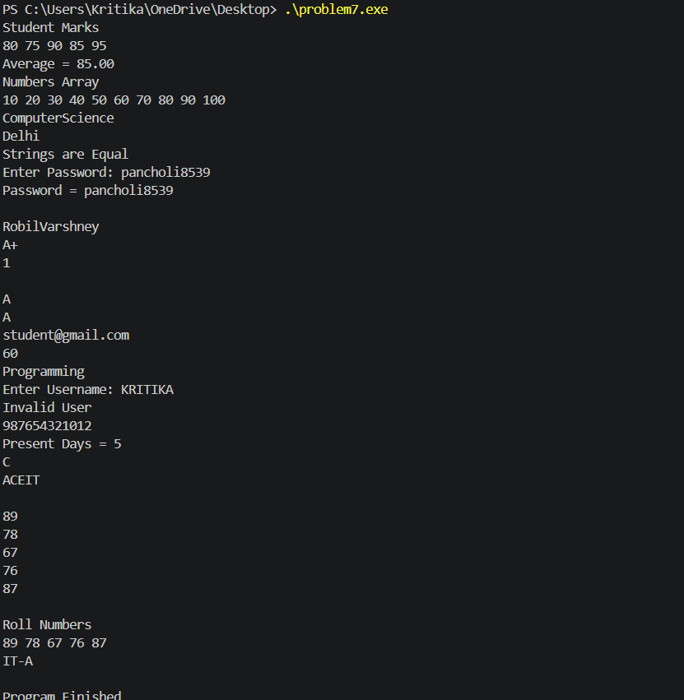
PROGRAM 8
Error Identification and Corrections
Line No. | Error Type | Error Description | Correction
15 | Semantic Error | Function add() requires 2 arguments but only 1 provided | add(num1, num2)
21 | Semantic Error | Function average() requires 3 arguments but only 2 provided | average(70,80,90)
61 | Semantic Error | Function calculateGrade() not declared or defined | Define function or remove call
67 | Semantic Error | Function circleArea() not declared or defined | Define function
75 | Semantic Error | Function sumArray() not declared or defined | Define function
81 | Semantic Error | Function displayResult() not declared or defined | Define function
94 | Logical Error | Average calculation may lose precision | (a+b+c)/3.0
100 | Logical Error | Factorial of 0 should be 1, not 0 | return 1;
116 | Logical Error | Swap does not affect original variables (call by value) | Use pointers
126 | Logical Error | Maximum function returns smaller value | Return larger value
139 | Logical Error | Recursive Fibonacci formula incorrect | fibonacci(n-1)+fibonacci(n-2)
156 | Logical Error | Integer division in percentage calculation | (marks*100.0)/total
166 | Syntax Error | Function returns float but uses return; | return si;
180 | Logical Error | Power loop runs one time less | i<=exp
197 | Semantic Error | Function does not return value | return rev;
220 | Logical Error | Prime function returns 1 for non-prime | Return 0 when divisible
239 | Runtime Error | Array loop accesses out of bounds (<=size) | Use < size
247 | Runtime Error | Infinite recursion | Add base condition
258 | Logical Error | Rectangle area formula incorrect | length * width
268 | Logical Error | Cube function returns square | n*n*n
Total Errors Identified: 20
Corrected code:
#include <stdio.h>

int add(int a, int b);
float average(int a, int b, int c);
int factorial(int n);
void swap(int *a, int *b);
int maximum(int a, int b);
int fibonacci(int n);

int main()
{
int num1 = 10;
int num2 = 20;

int result = add(num1, num2);

printf("Sum = %d\n", result);

float avg = average(70,80,90);

printf("Average = %.2f\n", avg);

int fact = factorial(5);

printf("Factorial = %d\n", fact);

int x = 100;
int y = 200;

printf("Before Swap\n");
printf("%d %d\n", x, y);

swap(&x,&y);

printf("After Swap\n");
printf("%d %d\n", x, y);

int max = maximum(15,25);

printf("Maximum = %d\n", max);

int fib = fibonacci(10);

printf("Fibonacci = %d\n", fib);

return 0;
}

int add(int a, int b)
{
return a + b;
}

float average(int a, int b, int c)
{
return (a + b + c) / 3.0;
}

int factorial(int n)
{
if(n == 0)
return 1;

return n * factorial(n - 1);
}

void swap(int *a, int *b)
{
int temp = *a;
*a = *b;
*b = temp;
}

int maximum(int a, int b)
{
if(a > b)
return a;
else
return b;
}

int fibonacci(int n)
{
if(n == 0)
return 0;
if(n == 1)
return 1;

return fibonacci(n-1) + fibonacci(n-2);
}
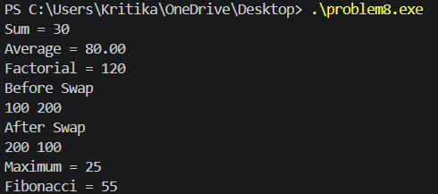

PROGRAM 9
Error Identification and Corrections
Line No. | Error Type | Error Description | Correction
12 | Runtime Error | Uninitialized pointer ptr1 dereferenced | Initialize pointer before use
16 | Runtime Error | NULL pointer dereferenced (*ptr2) | Allocate memory or assign valid address
24 | Runtime Error | Pointer increment causes invalid memory access | Do not access beyond valid object
30 | Runtime Error | Array index out of bounds (ptr4 + 10) | Use valid index within array
42 | Runtime Error | Accessing memory after free(ptr5) | Do not use pointer after free
50 | Logical Error | Memory leak (ptr6 set to NULL before free) | Call free(ptr6) before assigning NULL
58 | Runtime Error | Allocated only 5 bytes but used as 10 integers | Allocate sufficient memory
72 | Runtime Error | Array index out of bounds (ptr8[3]) | Allocate larger array or remove access
84 | Runtime Error | Double free of pointer | Free memory only once
92 | Runtime Error | Uninitialized allocated memory printed | Assign value before printing
98 | Runtime Error | Loop condition i<=5 accesses beyond allocated memory | Use i<5
114 | Semantic Error | pptr = &value; type mismatch | pptr = &ptr; where ptr is int*
122 | Runtime Error | Buffer overflow in strcpy() | Allocate enough memory
134 | Runtime Error | Pointer increment then dereference invalid memory | Do not increment allocated single element
140 | Runtime Error | NULL pointer dereferenced in condition | Check pointer before dereference
154 | Runtime Error | Array index out of bounds (ptr13[100]) | Use indices 0–99
162 | Runtime Error | Use after free (*ptr14) | Do not access freed memory
170 | Semantic Warning | matrix assigned to int* improperly | Use int *p = &matrix[0][0];
172 | Runtime Error | Access beyond matrix bounds (p + 20) | Use valid index
178 | Logical Error | Memory leak (first malloc lost) | Free memory before reassigning
190 | Runtime Error | Loop condition i<=size accesses extra element | Use i<size
182-186 | Logical Error | Swap function swaps pointers, not values | Swap dereferenced values
Total Errors Identified: 22
Corrected code:
#include <stdio.h>
#include <stdlib.h>
#include <string.h>

void swap(int *a, int *b);
void printArray(int *arr, int size);

int main()
{
int x = 10;
int y = 20;

int *ptr1 = &x;
printf("%d\n", *ptr1);

int value2 = 100;
int *ptr2 = &value2;
*ptr2 = 100;

int *ptr3 = &x;
printf("%d\n", *ptr3);

int arr[5] = {10,20,30,40,50};
int *ptr4 = arr;

printf("%d\n", *(ptr4 + 2));

int *ptr5 = malloc(sizeof(int));
*ptr5 = 500;

printf("%d\n", *ptr5);

free(ptr5);
ptr5 = NULL;

int *ptr6 = malloc(sizeof(int));
*ptr6 = 1000;

free(ptr6);
ptr6 = NULL;

int *ptr7 = malloc(10 * sizeof(int));

for(int i=0; i<10; i++)
{
ptr7[i] = i;
}

free(ptr7);

int *ptr8 = malloc(4 * sizeof(int));

ptr8[0] = 10;
ptr8[1] = 20;
ptr8[2] = 30;
ptr8[3] = 40;

free(ptr8);

int *ptr9 = malloc(sizeof(int));
*ptr9 = 50;

free(ptr9);
ptr9 = NULL;

int *ptr10 = malloc(sizeof(int));
*ptr10 = 250;

printf("%d\n", *ptr10);

int *numbers = malloc(5 * sizeof(int));

for(int i=0; i<5; i++)
{
numbers[i] = i * 10;
}

printArray(numbers,5);

int a = 100;
int b = 200;

swap(&a,&b);

printf("%d %d\n", a, b);

int value = 500;
int *ptr = &value;
int **pptr = &ptr;

printf("%d\n", **pptr);

char *name = malloc(20);
strcpy(name,"Programming");

printf("%s\n", name);

int *ptr11 = malloc(sizeof(int));
*ptr11 = 123;

printf("%d\n", *ptr11);

int value12 = 5;
int *ptr12 = &value12;

if(*ptr12 > 0)
{
printf("Positive\n");
}

int *ptr13 = malloc(100 * sizeof(int));

for(int i=0;i<100;i++)
{
ptr13[i] = i;
}

int *ptr14 = malloc(sizeof(int));
*ptr14 = 999;

printf("%d\n", *ptr14);

int matrix[3][3];

int *p = &matrix[0][0];

printf("%d\n", *p);

int *ptr15 = malloc(sizeof(int));

free(ptr15);

free(numbers);
free(ptr10);
free(ptr11);
free(ptr13);
free(ptr14);
free(name);

printf("End of Program\n");

return 0;
}

void swap(int *a, int *b)
{
int temp;

temp = *a;
*a = *b;
*b = temp;
}

void printArray(int *arr, int size)
{
for(int i=0; i<size; i++)
{
printf("%d ", arr[i]);
}

printf("\n");
}
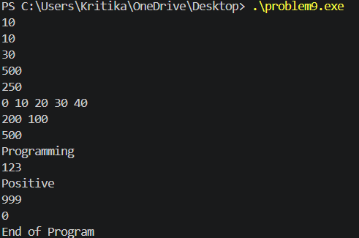
PROGRAM 10
Error Identification and Corrections
Line No. | Error Type | Error Description | Correction
12 | Syntax Error | Missing semicolon after int choice = 1 | int choice = 1;
14 | Semantic Error | String assigned to integer variable | int marks = 90;
20 | Semantic Error | Function add() requires 2 arguments but only 1 provided | add(a,b)
24 | Logical Error | Assignment operator used instead of comparison | if(a == b)
29 | Semantic Error | Variable score not declared | Declare variable before use
33 | Runtime Error | Array index out of bounds (arr[10]) | Use valid index (0-4)
35 | Runtime Error | Negative array index (arr[-1]) | Use valid index
39 | Runtime Error | Buffer overflow in strcpy() | Increase array size
45 | Syntax Error | Cannot assign string directly to array | strcpy(city,"Delhi");
53 | Logical Error | String compared using == | Use strcmp(user,"admin")==0
61 | Runtime Error | Division by zero (x/y) | Ensure y != 0
65 | Runtime Error | NULL pointer dereference | Assign valid address
69 | Runtime Error | Uninitialized pointer dereference | Initialize pointer
79 | Runtime Error | Use after free | Do not access pointer after free()
81 | Runtime Error | Double free of pointer | Free memory only once
89 | Runtime Error | Allocated 5 bytes but accessed as 10 integers | Allocate sufficient memory
97 | Logical Error | Memory leak (old malloc lost) | Free old memory before reassignment
101 | Semantic Error | average() requires 3 arguments but only 2 provided | average(70,80,90)
109 | Logical Error | Voting eligibility condition reversed | if(age >= 18)
121 | Logical Error | Prime logic incorrect | Set isPrime = 0 when divisible
127 | Logical Error | Prime output reversed | Print "Prime" when isPrime==1
133 | Semantic Error | calculateSalary() not declared/defined | Define function or remove call
141 | Runtime Error | File may not exist (abc.txt) | Check fp != NULL
149 | Syntax Error | Missing colon after case 1 | case 1:
154 | Logical Error | Missing break in case 2 | Add break;
160 | Semantic Error | Multi-character constant 'AB' | Use 'A'
168 | Runtime Error | Array index out of bounds (scores[3]) | Increase array size or remove access
172 | Runtime Error | Loop condition i<=3 accesses extra element | Use i<3
182 | Logical Error | Wrong formula for circle area | 3.14 * radius * radius
186 | Logical Error | Extra semicolon after while | Remove semicolon
191 | Semantic Error | continue used outside loop | Remove statement
202 | Logical Error | Integer division in average function | Use /3.0
Total Errors Identified: 32
Corrected code:
#include <stdio.h>
#include <stdlib.h>
#include <string.h>

int add(int a, int b);
float average(int a, int b, int c);
void displayReport();

int totalStudents = 500;

int main()
{
int choice = 1;

int marks = 90;

int a = 10;
int b = 20;

int result = add(a,b);

printf("Sum = %d\n", result);

if(a == b)
{
printf("Equal\n");
}

int score = 100;
printf("%d\n", score);

int arr[5];
arr[4] = 100;

printf("%d\n", arr[0]);

char name[25];
strcpy(name, "ProgrammingLanguage");

printf("%s\n", name);

char city[20] = "Jaipur";
strcpy(city, "Delhi");

printf("%s\n", city);

char user[20];

scanf("%19s", user);

if(strcmp(user, "admin") == 0)
{
printf("Valid User\n");
}

int x = 100;
int y = 10;

printf("%d\n", x/y);

int value1 = 500;
int *ptr1 = &value1;

printf("%d\n", *ptr1);

int value2 = 100;
int *ptr2 = &value2;

printf("%d\n", *ptr2);

int *ptr3 = malloc(sizeof(int));

*ptr3 = 100;

printf("%d\n", *ptr3);

free(ptr3);

int *ptr4 = malloc(10 * sizeof(int));

for(int i=0;i<10;i++)
{
ptr4[i] = i;
}

free(ptr4);

float avg = average(70,80,90);

printf("%f\n", avg);

int age = 17;

if(age >= 18)
printf("Eligible\n");
else
printf("Not Eligible\n");

int num = 13;

int isPrime = 1;

for(int i=2;i<num;i++)
{
if(num%i==0)
{
isPrime = 0;
break;
}
}

if(isPrime)
printf("Prime\n");
else
printf("Not Prime\n");

displayReport();

printf("%d\n", totalStudents);

FILE *fp = fopen("abc.txt","r");

if(fp != NULL)
{
fscanf(fp,"%d",&num);
fclose(fp);
}

switch(choice)
{
case 1:
printf("One\n");
break;

case 2:
printf("Two\n");
break;

default:
printf("Other\n");
}

char grade = 'A';

printf("%c\n", grade);

int scores[4];

scores[0]=10;
scores[1]=20;
scores[2]=30;
scores[3]=40;

int total = 0;

for(int i=0;i<4;i++)
{
total += scores[i];
}

printf("%d\n", total);

int radius = 5;

float area;

area = 3.14 * radius * radius;

printf("%f\n", area);

while(choice > 0)
{
choice--;
}

printf("Program Completed\n");

return 0;
}

int add(int a, int b)
{
return a + b;
}

float average(int a, int b, int c)
{
return (a+b+c)/3.0;
}

void displayReport()
{
printf("Report Generated\n");
}
